Step 1: Open the MABS console, navigate to protection group and select the required protection group member which we need to remove.

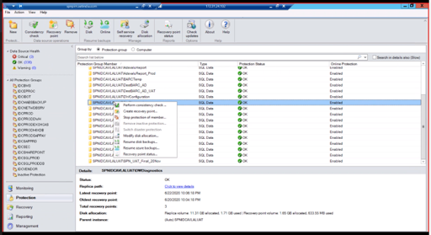

Step 2: Right click on the desired protection group and click on “Stop Protection of member”

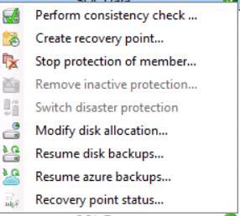

Step 3: Once clicked it will navigate to another dialogue box, in which select “ Delete Replica on disk” and click on OK.

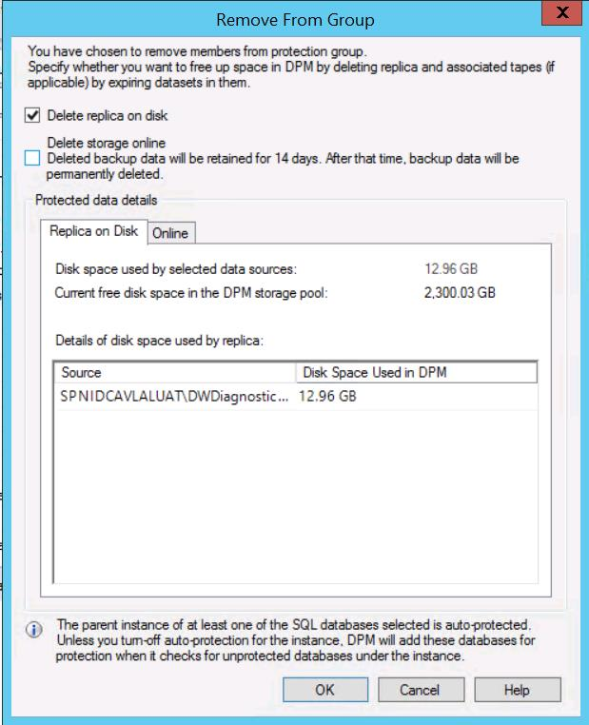

Step 4: Once done, it will take some time to remove.